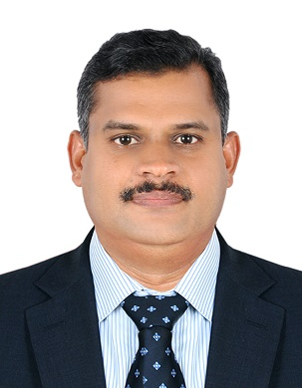
MOHAMMED SALEEM
Dubai
050-4097916
saleempam@gmail.com

COLLECTION EXECUTIVE (13 YEARS)
Sending the invoices to the owners
Handle heavy direct owners Telephone Collection of past due invoices.
Resolve owner’sproblems with their accounts for all or any invoices/billings
Handle heavy incoming phone coverage to resolve customer problems with billings/ payments
Recommending and implementing collection process improvements and participation in people soft upgrades and improvement projects that deal with collections.
Assist in resolving and reconciliation of complex people soft payment applications
Work with and provide guidance to collections representatives in resolving complex account issues
Interacting with clients to get the correct information on the dispute and give the defaulter party a proper settlement plan.
Weekly field visits to defaulter party offices to have meeting and do negotiations on the claim amount.
To monitor and manage daily activity by liaising with customer over telecom or direct visits negotiate on account collection to minimize the risk of the assigned portfolio.
Positively managing and visiting’’ High net worth individual’” client’s portfolio initiate collection processes to recovery payments on loans, in order to get maximum collections.
Identifying delinquent unsecured accounts and ensuring appropriate actions are implemented to maximize debt collections.
Coordinating with banker and customers to ensure a streamlined, time/cost effective collection process.
Achieving the set targets by the management and consistently over delivering the expected numbers.
To monitored manage daily activity by liaising with customers over telecom or direct visits to negotiate on account collection to minimize the rizk of the assigned portfolio.
Positively managing and visiting “High net worth individual”’ client’s portfolio initiate collection process to recovery payments on loans, in order to get maximum collections.
Identifying delinquent unsecured accounts and ensuring appropriate actions are implemented to maximize process.
Achieving the set targets by the management and consistently over delivering the expected numbers.
Upload the data into strata ware software.
Collecting payments for real estate.
Collecting payments for insurance companies.

Pro
• Assisting with all aspects of administrative management, directory maintenance.
• Handling the all documents related to Economic Development for Trade License procedure.
• Preparing and typing documents of Ministry of Labour, Immigration and other departments.
• Processing of all Documents related with Vehicle.
• Drafting the letters and applications in Arabic and English.
• Typing of various application forms and formats Machine and Computer in Arabic and English.
• Contacts with various governmental departments and document clearance.
• Managing Day-to-day Office Accounts and Bank accounts.

ACADAMIC QUALIFICATIONS
• Bachelor of Arts (BA)
LANGUAGES KNOWN
Arabic (Reading, Speaking, Writing)
English (Reading, Speaking, Writing)
Hindi (speaking)
Malayalam (mother tongue)
COMPUTER SKILLS
Ms Excel, Word, Outlook
Typing (Arabic & English)

PERSONAL DETAILS
Date of birth: 28-05-1978
Nationality: India
Visa status: Visit visa
Driving License: Four light vehicle issued by Dubai.
Marital status. Married

