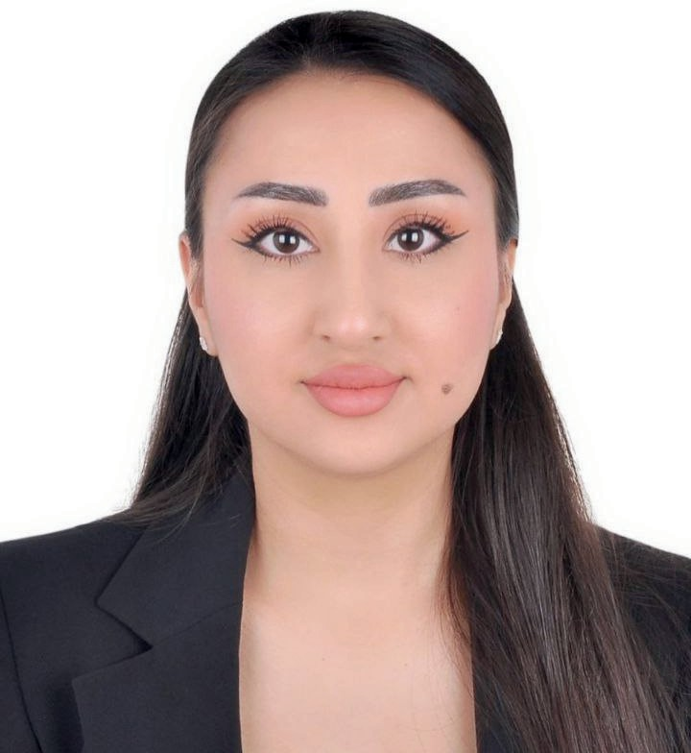
Education

2016-2021

2017-2018
Tajik National University
Jornalist-Translator
Murray State University, Kentucky, USA
English as a second language




QADAMZODA FARZONAI
qadamzodafarzona@ gmail.com
+971 52 492 44 62
Al Barsha South, Street 87, Villa 34
About me
I am a skilled professional with a background in journalism, hospitality, and real estate. With experience in guest relations, property management, and administration at companies like Aeon & Trisl, Haus & Haus, and Emaar Hospitality, I excel in delivering exceptional service. Fluent in English, Russian, and Tajik, (Persian) and with education from Tajik National University and Murray State University, I bring strong organizational and communication skills, enhanced by international experience.
Skills
Excellent organizational and time management skills. on front desk operations
Experienced engagement planning.
in and
youth activity
Skilled in multitasking and attention to detail.
Proficient in Microsoft Office, Google Suite.

Professional Experience

Aeon & Trisl Real Estate Broker L.L.C. (Nov 2024– Present)
Sales and admin assistant specializing in lead
management, Property listings,
Arrange the meeting either via Zoom and in person.

Haus & Haus Holiday Rental (Apr 2024–Nov 2024)
Guest Relations Coordinator managing tenant relations,
Check-ins/outs,
Maintenance coordination across properties.

Emaar Hospitality (Address Residences Dubai Opera) (Jul 2023–Mar 2024)
Executive Facilities Supervisor handling apartment inventory handovers and defect liability follow-ups.

Central Hotels & Resorts (Royal Central Hotel and Resort The Palm) (Jan 2022–Jul 2023)

Guest Service Agent focusing on front desk operations,
Guest relations and complaint resolution.

Hyatt Regency Dushanbe (Aug 2020–Jan 2022)
Receptionist managing reservations, guest check-ins/outs, and transportation arrangements.

Languages
Persian English Russia

